Day 66: D Flip-Flop with Set and Reset

Introduction: A D Flip-Flop with Set and Reset is a sequential circuit used to store one bit of data. The Set input forces the output Q to 1, while the Reset input forces Q to 0. The D input determines the stored data at the active clock edge during normal operation. In this project, a D Flip-Flop with Set and Reset is designed using Verilog HDL and simulated using Xilinx Vivado.

with Set

Design:

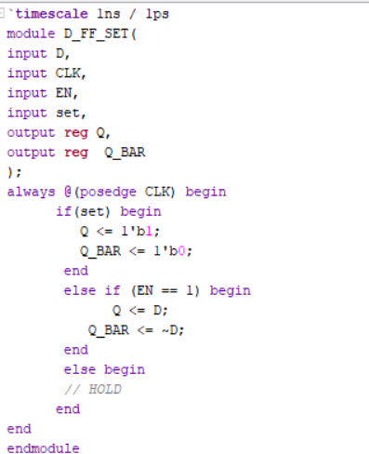

Testbench:

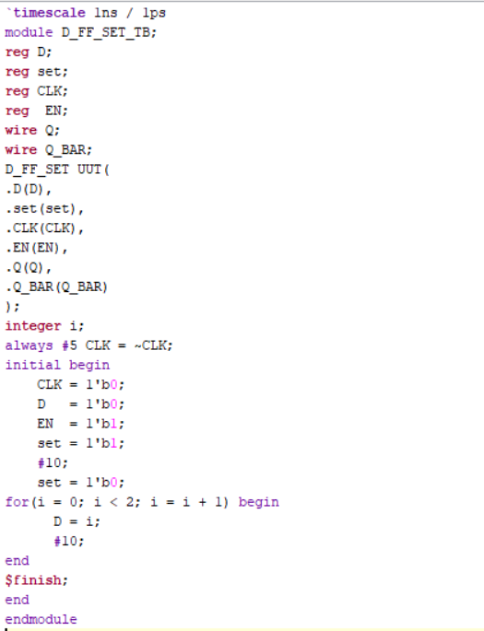

Waveform:

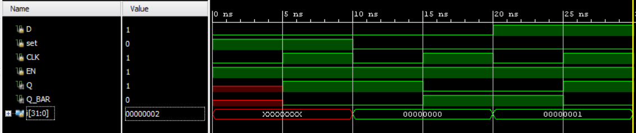

Schematic:

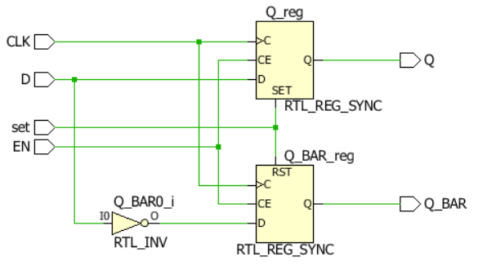

with Reset

Design:

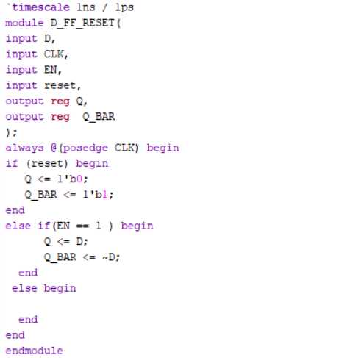

Testbench:

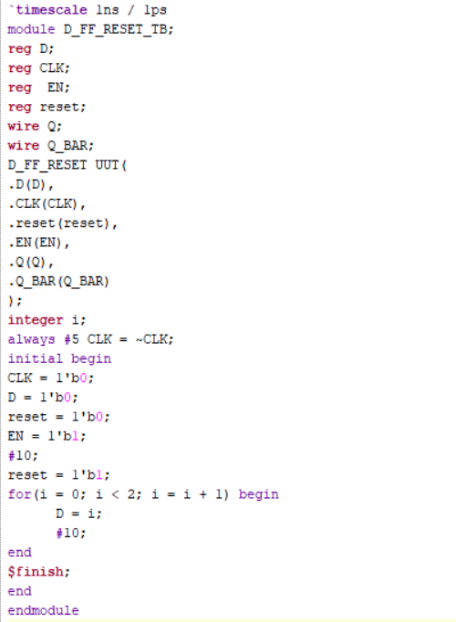

Waveform:

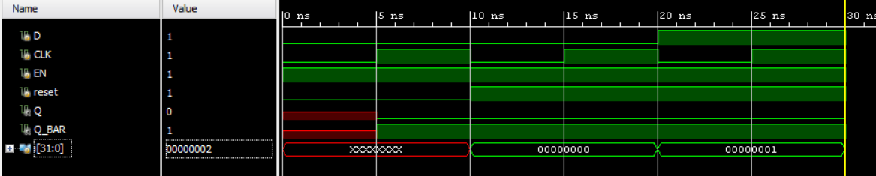

Schematic:

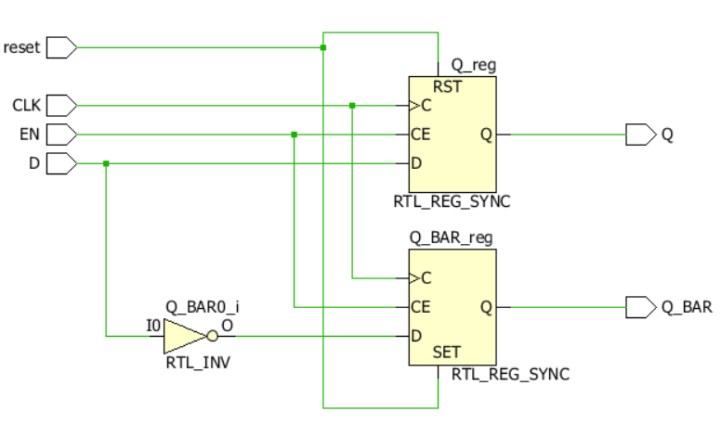

with Set and Reset

Design:

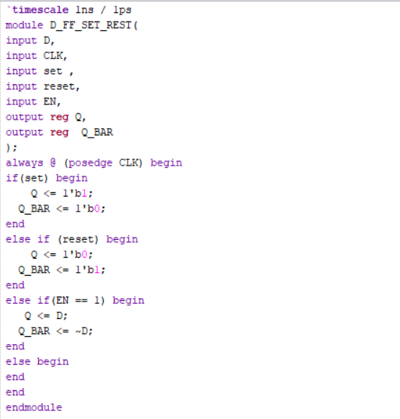

Testbench

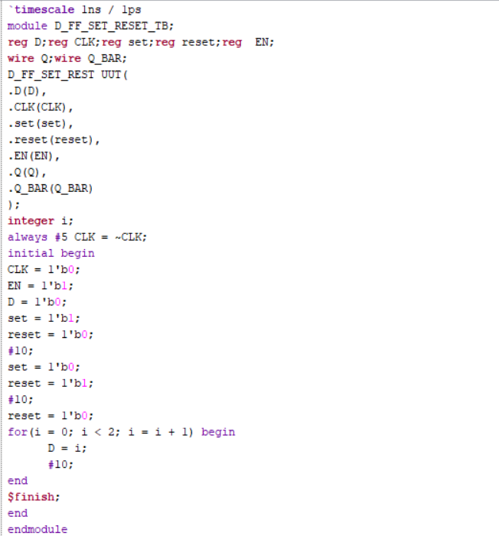:

Waveform:

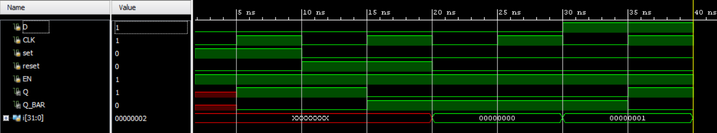

Schematic:

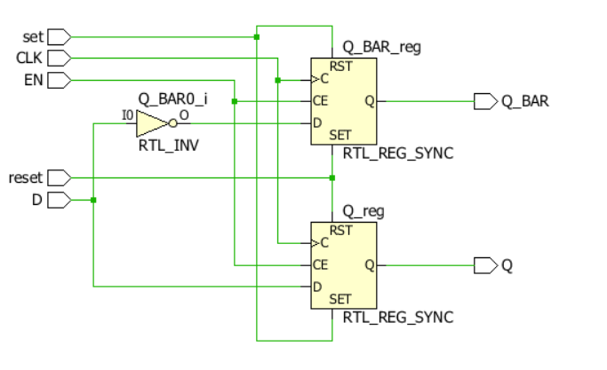

Observation:The D Flip-Flop with Set and Reset was implemented and verified through simulation in Xilinx Vivado. The Set input forces Q to 1, and the Reset input forces Q to 0. During normal operation, the output follows the D input at the active clock edge. The simulation waveforms were observed to verify the circuit's functionality.

#PHANEENDRA.SINGUDASU

